1.

M = {1, 2, 3, 8, 10} and N = {8, 1, x, 3, 2}.
If M is equal to N, what is the value of x?
A.
1
B.
2
C.
3
D.
8
E.
10

2.

In the Venn diagram Q is the set of numbers inside the circle and R is the set of numbers inside the triangle.
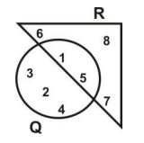
Find Q ∩ R.
A.
{1, 5}
B.
{2, 3, 4}
C.
{6, 7, 8}
D.
{1,2,3,4,5}
E.
{1,2,3,4,5,6,7,8}

3.

Simplify: 11 – (11 – 4) + 13.
A.
–7
B.
–17
C.
9
D.
17
E.
31

4.

What is the value of ‘4’ in the number 2,043,507?
A.
Forty
B.
Four hundred
C.
Four thousand
D.
Forty thousand
E.
Four hundred thousand

5.

Which of the following is true?
A.
{0, 2, 6, 9, 12} is a subset of even numbers.
B.
{-1, 0, 2, 3, 5} is a subset of odd numbers.
C.
{-2, -1, 1, 3, 9} is a subset of integers.
D.
{2, 3, 5, 7, 27} is a subset of prime numbers.
E.
{9, 18, 21, 27, 36} is a subset of multiples of 9.

6.

If (23 × 82) × 79 = 148,994, find the exact value of (2.3 × 82) × 7.9
A.
1.48994
B.
14.8994
C.
148.994
D.
1489.94
E.
14899.4

7.

Convert 206 to a base five numeral.
A.
411_{five}
B.
4011_{five}
C.
3321_{five}
D.
1311_{five}
E.
1131_{five}

8.

Which of the following inequalities is represented by the number line?
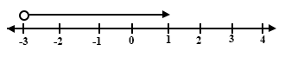
A.
x ≤ -3
B.
x ≥ -3
C.
x < -3
D.
x > -3
E.
x = -3

9.

The product of three numbers is 1197. Two of the numbers are 3 and 21. Find the third number.
A.
19
B.
57
C.
63
D.
399
E.
1134

10.

Simplify:
(
-2
3
)
-
(
1
5
)
.
A.
(
-1
2
)
B.
(
-1
8
)
C.
(
-3
8
)
D.
(
-1
-2
)
E.
(
-3
-2
)

11.

A pencil sells at ₵180.00 and an eraser sells at ₵120.00. how much will you pay if you buy three pencils and four erasers?
A.
₵1,020.00
B.
₵1,080.00
C.
₵1,200.00
D.
₵1,280.00
E.
₵2,100.00

12.

Simplify
0.12 x 0.08
2.40
A.
0.4
B.
0.04
C.
0.004
D.
0.0004
E.
0.00004

13.

How many lines of symmetry has a square?
A.
2
B.
3
C.
4
D.
6
E.
8

14.

In the diagram, MNO is a right angled triangle. |MO| = 13 cm and |MN| is 5 cm.
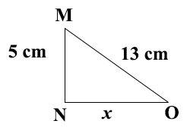
Find the value of x.
A.
3
B.
4
C.
8
D.
12
E.
18

15.

Amina spends
17
35
of her pocket money on transport and food. If she spends
2
7
on transport only, what fraction does she spend on food?
A.
1
4
B.
1
5
C.
5
7
D.
15
28
E.
18
35

16.

If x →3x – 4, what is the image of –2?
A.
–10
B.
–2
C.
–1
D.
2
E.
10

17.

Simplify: (2ab²) (3a²b)
A.
5a²b²
B.
6a²b²
C.
5a²b³
D.
6a³b²
E.
6a³b³

18.

It takes 15 men, 48 days to weed a plot of land. How many men can weed the same plot of land in 16 days, if they work at the same rate?
A.
5
B.
18
C.
32
D.
45
E.
48

19.

The ratio 9 : x is equivalent to 36 : 20. What is the value of x?
A.
4
B.
5
C.
6
D.
8
E.
10

20.

In an enlargement, PQ→P′Q′. |PQ| = 3 cm and |P′Q′| = 15 cm. Calculate the scale factor of the enlargement.
A.
1
5
B.
2
3
C.
5
D.
10
E.
45

21.

Simplify: 7a – 3(b – a)
A.
4a – 3b
B.
6a – 3b
C.
8a – 3b
D.
10a – 3b
E.
10a + 3b

22.

A man deposited an amount of money in his savings account for 5 years. The rate of interest was 14% per annum. If the interest was ₵35,000.00, find the amount deposited.
A.
₵85,000.00
B.
₵50,000.00
C.
₵39,900.00
D.
₵24,500.00
E.
₵15,000.00

23.

Arrange the following fractions from the lowest to the highest:
3
4
,
2
3
and
3
5
.
A.
3
5
,
2
3
,
3
4
B.
3
5
,
3
4
,
2
3
C.
3
4
,
2
3
,
3
5
D.
3
4
,
3
5
,
2
3
E.
2
3
,
3
5
,
3
4

24.

The marked price of a radio set is ₵450,000. A discount of 5% of the marked price is allowed. What is the selling price of the radio set?
A.
₵427,000
B.
₵427,500
C.
₵428,571
D.
₵472,500
E.
₵473,684

25.

If 60% of the pupils in a school is 240, find the total enrolment in the school.
A.
144
B.
160
C.
360
D.
384
E.
400

26.

If a * b = 2a – b, evaluate 4 * 3
A.
1
B.
2
C.
3
D.
4
E.
5

27.

The bar chart shows the mark distribution of pupils in a test. Use it to answer the question below
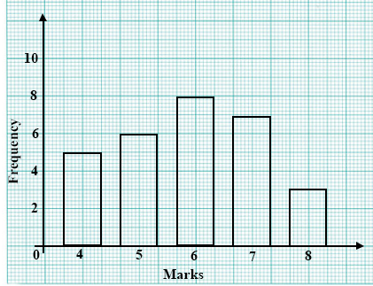
What is the modal mark?
A.
4
B.
5
C.
6
D.
7
E.
8

28.

The bar chart shows the mark distribution of pupils in a test. Use it to answer the question below
How many pupils took the test?
A.
5
B.
20
C.
25
D.
29
E.
30

29.

A school has a population of 600. Out of this, 120 are girls. What is the probability of meeting a pupil in the school who is a boy?
A.
1
4
B.
1
5
C.
3
5
D.
4
5
E.
12
25

30.

If
1
k
=
1
k
1
+
1
k
2
, find k when k₁ = 1 and k₂ = 2.
A.
1
2
B.
2
3
C.
3
2
D.
2
E.
3

31.

Solve the equation 13x – 2(3x + 4) = 22.
A.
2
B.
4
C.
18
7
D.
26
7
E.
30
7

32.

A rectangular tank is 4 m long, 3 m wide and 2.5 m high. What is the volume of the tank?
A.
24 m³
B.
30 m³
C.
36 m³
D.
48 m³
E.
60 m³

33.

Write the rule for the mapping:
x | 1 | 2 | 3 | 4
↓ | ↓ | ↓ | ↓ | ↓
y | 1 | 3 | 5 | 7
A.
x→2x + 1
B.
x→2x - 1
C.
x→2(x + 1)
D.
x→2(x - 1)
E.
x→x²- 1

34.

If r =
(
2
-1
)
and s =
(
-3
2
)
, calculate 2r - 3s.
A.
(
-5
12
)
B.
(
-5
-8
)
C.
(
13
-3
)
D.
(
13
-8
)
E.
(
13
8
)

35.

Name the geometrical figure shown in the diagram below.
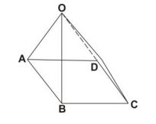
A.
parallelogram
B.
triangle
C.
cone
D.
tetrahedron
E.
pyramid

36.

A car travels 72 kilometres in an hour. Find its speed in metres per second.
A.
5 ms⁻¹
B.
20 ms⁻¹
C.
50 ms⁻¹
D.
200 ms⁻¹
E.
1200 ms⁻¹

37.

The circumference of a circular track is 154 m. Find the diameter of the track.
[Take π =
22
7
]
A.
22.0 m
B.
24.5 m
C.
49.0 m
D.
242.0 m
E.
484.0 m

38.

Find the value of the angle marked y in the diagram.
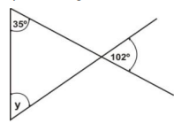
A.
35°
B.
43°
C.
67°
D.
78°
E.
137°

39.

Which of the following best describes the construction in the diagram?
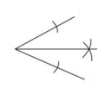
A.
Constructing a 30° angle.
B.
Constructing a 60° angle.
C.
Bisecting a line segment.
D.
Bisecting a given angle.
E.
Drawing a perpendicular from a given point.

40.

Ama is N years old now. How old will she be in 10 years?
A.
(N – 10) years
B.
(N + 10) years
C.
(10 – N) years
D.
10 N years
E.
10
N
years

